ANDROID APPLICATION FOR BUS TRACKING AND MANAGEMENT SYSTEM USING GSM/GPS

K Revanth¹, Raja Preetham², P.Vishnu Sai³, Raja Yaswanth⁴ ,Dr.G.Sundari⁵
^{1,2,3,4} UG Scholar, ⁵ Dean Student Affairs
Department of Electronics and Communication Engineering
Sathyabama University, Chennai, India.

ABSTRACT- This project provides us a solution for enhancing public transportation management services based on GPS/GSM module. A new service, to facilitate the people who use public transport for travelling is introduced. The Bus Tracking android application enables user to find out the location of the bus. The system comprises of PIC microcontroller, GPS module and GSM modem. GPS module is used to collect the Latitude and Longitude readings and using GSM modem the readings are send to server so that it can be fetched by an android application and the bus real time location can be viewed on Google map, which is integrated onto the android application. This service removes the need of waiting at the bus stops and this saves lot of time. The user can sign up in the application and can know about the scheduled routes of the bus and the exact location of the bus and he plans his works according to the bus timings. This application is user-friendly and flexible to use and it is also a time saving application to the user.
Key Words: GPS, GSM, PIC MICROCONTROLLER

1. INTRODUCTION
Android is highly suitable for expansion as the developer sees fit. This project for the benefit of the student needs by the idea of providing an easier means of accessing various and different web resources related to the bus services ,thus providing them with a better experiences and facilities in travelling. Further, the popularity of Android technology motivates us to create an Android application for the same.
This system will make use of GSM and GPS modules to get exact and real time location of bus and for that we are using a PIC microcontroller along with GSM and GPS module.
In Real time vehicular tracking system, a hardware device is installed in the vehicle. The information is transmitted to web server using GSM modem. Server receives vehicle location information via GSM network and stores this information in database.
This module will be provided with a SIM card for communication purpose. GPS will give the longitude and latitude values and those values are transmitted to the server with the help of GSM module. Once the longitude and latitude values are uploaded to the server, the user with the help of android application will be able to download from server and get the exact location of the college bus, which he can see it through the Google maps integrated in it.

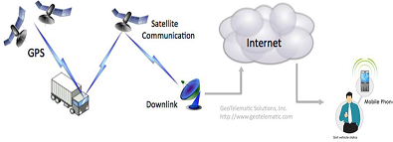
Figure 1. Architecture
2. EXISTING SYSTEM
The existing system consists of Radio Frequency Identification (RFID) reader and integrated sensing technologies such as GPS and general packet radio service (GPRS) and Geographic Information System (GIS). This system consists of 3 modules that are BUS module, BUS Stop module, BASE Station module .In BUS module, it sends the location information to the BASE station module and BASE station module is equipped with a micro controller unit.the BASE station module send information to BUS Stop module about buses arriving the particular bus stop and also send SMS to mobile phones about particular buses.. In this system the user does not know the exact location of the bus , as the user receives only an SMS consisting of the bus stop name which the bus had already crossed and the bus stop name which the bus is going to arrive .In some systems a display board is put in the bus and the location of the bus is displayed on the display board. Sometimes, the bus may get delayed due to heavy traffic congestion and traffic signals . Then the user will not be able to decide whether the bus has arrived or not. Due to this, the user may face many problems.

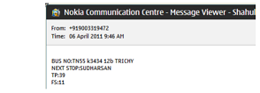
Figure2. SMS showing information

The main disadvantage of the existing system is that this system consists of more number of GPS and GSM modules which are costly and it is a two way communication .First we have to send an SMS requesting the location of the bus and then from the bus server we have to receive an SMS containing the last addressed bus stop name and location . This system provides only a particular geographical address, and does not provide street wise address.

3. PROPOSED SYSTEM
3.1 Objectives
For the proposed research work following objectives have been framed.To analyze the working of existing android based Vehicle Tracking Systems.To propose the framework for android based Vehicle Tracking System to track the current position of the vehicle and the estimated arrival time.To develop the server side module for the vehicle to send the location coordinates (latitude and longitude) to the client (commuter).To develop the client side module for the commuters to receive the location coordinates from the vehicle and map the vehicle location onto Google map.
To test and validate the proposed GPS based vehicle tracking system.To set reminder needed for the bus One of the objectives that must be achieved is to create a pop up to remind that bus is arriving to the user specified location so that user can know the exact arrival of the bus.To record all maintenance activities each and every bus entry and exit timings are tabulated and saved in the database. It reduces the manpower and also accuracy will be high. To implement search by using recursive Search user can track the bus all along it’s route in android application .It helps user to know time to reach destination.

3.2 GPS DESCRIPTION
A GPS is a space-based navigation system that provides exact geographical location of vehicles and devices anywhere on Earth where there is an unobstructed line of sight to four or more GPS satellites
The GPS concept is based on time and the known position of specialized satellites. GPS satellites continuously transmit their current time and position. A GPS receiver monitors multiple satellites and solves equations to determine the precise position of the receiver and its deviation from true time. At a minimum, four satellites must be in view of the receiver for it to compute four unknown quantities.
Each GPS satellite continually broadcasts a signal (carrier wave with modulation) that includes a pseudorandom code (sequence of ones and zeros) that is known to the receiver and a message that includes the time of transmission (TOT) of the code epoch and the satellite position at that time.
A GSM module works as modem for transmitting the received GPS signals (Latitude and Longitude readings) to the database server. The data communication is done by using the GPRS (General Packet Radio Service). GSM consists of Subscriber Identity Module, commonly known as a SIM card. The SIM is a detachable smart card. Here in this system, we have used SIM 908 which is a Quad Band Module.

3.3 BLOCK DIAGRAM
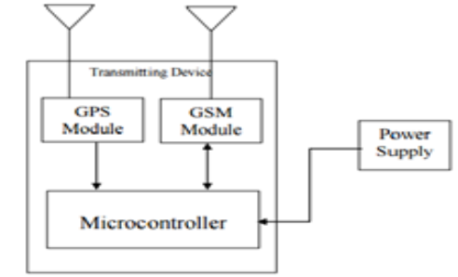
Figure3.Block Diagram

.
In the PROPOSED SYSTEM we use an PIC microcontroller. PIC is an open-source prototyping platform based on easy-to-use hardware and software. PIC boards are able to read inputs - light on a sensor, a finger on a button, and turn it into an output. The PIC board works on the instructions given to it .To give instructions to the PIC we here use the PIC Programming language and PIC software (IDE).

The PIC microcontroller receives the latitude and Longitude signals using GPS and transmits the signals to the server using GSM. The information in the server is used by the android application .The android application continuously takes the signals and updated automatically.

The user who wants to know the location of the bus will enter the bus number in the app and he will get the exact location of the bus.

3.4 EXPERIMENTAL SETUP
The main specifications of this setup are hardware and software interfaces. The Hardware Interfaces for this application are Client PC with Internet Connection, Server with Static IP, GSM SIM Card with GPRS activated. The Software Interfaces for this application are Android Studio and GOOGLE MAPS.

3.5 DESCRIPTION OF HARDWARE UNIT
The hardware unit is shown in below figure. This hardware unit consists of GPS module, GSM module and an PIC Microcontroller. The GSM is inserted with a SIM card and connected to the power supply.

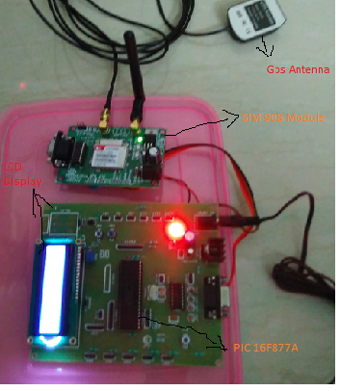
Figure3. Hardware Setup
The 16F877A is one of the most popular PIC microcontrollers and it's easy to operate and utilize its functions and it comes in a 40 pin DIP pin out and it has many internal peripheral units.
The 16F877A PIC microcontroller can do many tasks because it has a large enough programming memory of 8k words and 368 Bytes of RAM. This is enough to do many different tasks and programs required for us.
It consists of 40 pins that make easier to use the peripherals as the functions and they are spread out over the pins. This makes easier to decide what external devices are required to attach without worrying too much if there are not enough pins to do the job.
One of the main advantages is that each pin is only shared between two or three functions and it is so easier to decide the pin functions.
By using the commands the microcontroller takes the latitude and longitude values of the current position from the GPS module and passes it on to the GSM module. The GSM will connect to the server via the GPRS. Thus the values get stored into the database in the server.

3.6 DESCRIPTION OF SOFTWARE UNIT
Software unit comprises of many algorithms that are needed to be processed for the access of the information.. The below Figure 4 shows the entire procedure that is happening for obtaining the information.

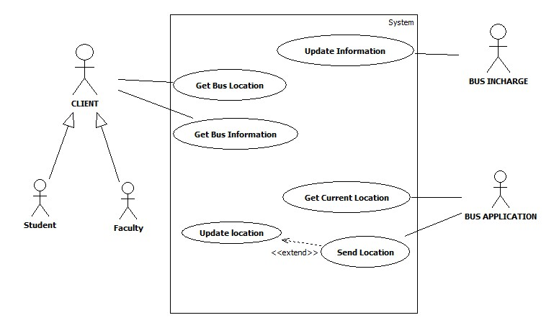
Figure4. User Case Diagram

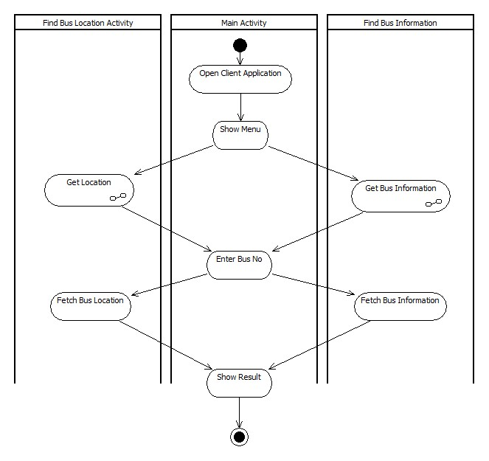
Figure 5. Activity Diagram
From the above figure 4. It clearly shows the activities that are processed for the transmitting and receiving of the information. And the steps that are involved to access the information and the selection of the options that are available to the user and to obtain the results.
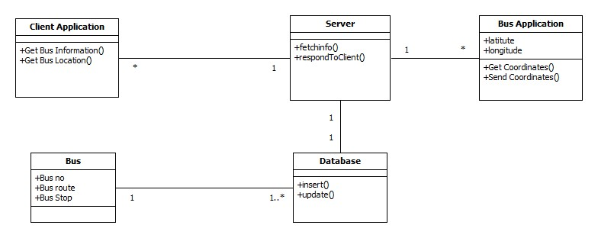
Figure6. Class Diagram

From the above Figure6 , it shows the different classes that are being involved in the process. Each process will be having different kinds of steps that are needed to be completed , so that required results can be obtained.

The Android Application is shown in below figure. This application will show the output through the Google maps. As soon as the user opens this app, the user needs to do registration by filling required details and then it shows the login page. Login page requires the username and password to access this application

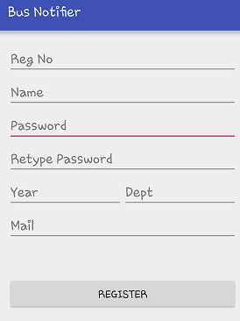
Figure7. REGISTRATION PAGE
And this provide the additional facility by selecting their bus stop, so that the user can be notified whether the bus has left the bus stop or not. Also this application can be useful to predict the arrival timings of the bus to bus stop.

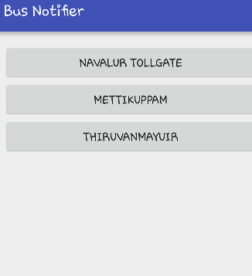
Figure 8 . BUS ROUTES

Once after login, the user can locate the bus by using the Google map. The Google map shows the exact location of the college bus. The location is fetched from the database of the server where the coordinates are stored. This location is transferred as a Google map and is shown to the user. The coordinates of the position of the bus is refreshed and stored in the server database for every 30 seconds.

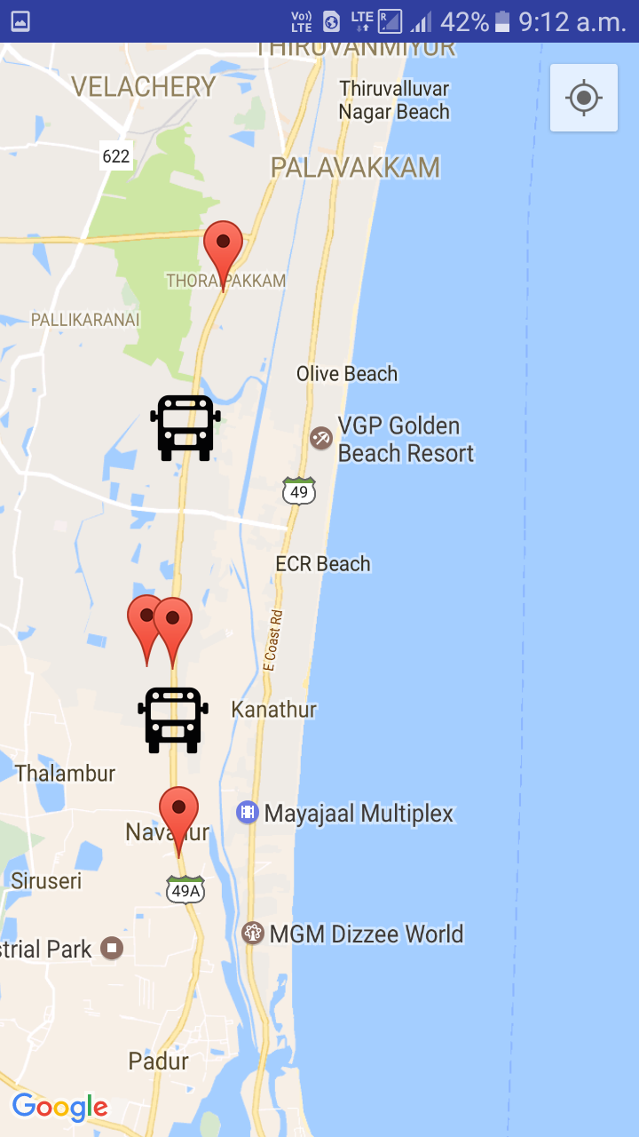

Figure 9. LOCATION OF THE BUS

4. CONCLUSION AND FUTURE WORKS

In order to track the bus , android application uses the help of GPS, GPRS, GSM and the Google maps .With this we even find the exact location of bus. This android application successfully shows the location of bus through Google maps integrated in it. This system can further be extended for many applications such as Anti-theft system for cars and bikes. ,Managing of public transports, Tracking of valuable assets and can be done many more applications and thus this system can prove to be helpful in coming years.

5. REFERENCES
[1] Jianye Liu, Jianaun Yu, “Research on Development of Android Applications”, 2011 Fourth International Conference on Intelligent Networks and Intelligent Systems, 2011.
[2] RobiGrgurina, GoranBrestovac and TihanaGalinacGrbac,“Development Environment for Android Application Development:an Experience Report”, MIPRO 2011.
[3] Mohol, AmitPavanikar, Ganesh DhageShintal and GPS Vehicle Tracking System, International Journal of Emerging Engineering Research and Technology, Volume 2, Issue 7, PP 71-75 ISSN 2349-4395, October 2014.
[4] AmbadeShrutiDinkar and S.A Shaikh, Design and Implementation Of Vehicle Tracking System Using GPS, Journal of Information Engineering and Applications, ISSN 2224-5758 ,Vol 1,No.3, 2011.
[5] Feng Huang, Shanyu Tang, Senior Member, IEEE, and JianYuan, Vehicle Location Based System, IEEE June, Transactions on no information forensics and security, vol.6,2,2011.
[6] Editorial Board, “Google API Go to application design, development, examples” Sung Gang Asset Management Corp.Limited, 2010.
[7] Wenzhong Li, Member, IEEE, Yuefei Hu, Student Member, IEEE, Xiaoming Fu, SeniorMember, IEEE, Sanglu Lu, Member, IEEE, and Daoxu Chen, Member, IEEE, “Cooperative Positioning and Tracking in DisruptionTolerant Networks”, IEEE, ISSN: 1045-9219, pp.1-11, 2014.
[8] ChakradharaRao CH, Pushpalatha P, and AdityaSundar N, ”GPS Based Vehicle Navigation System using Google Maps”, International Journal of Computer Science and Information Technologies, Vol.4, Issue.6, pp.1346-1352, 2013.
[9] Dr.(Mrs) SaylGhargl, Moral Chhaa, GauravChheda, Jitesh, and Niket, ”Real Time Bus Monitoring System using GPS”, VES Institute of Technology, Mumbai University, India, Vol.5, Issue.7, pp.1786-1792, 2013.
[10] Vehicle Tracking Bangalore, http://www.simbaprojects.org/download/india/present aion%20and%20feedback/ITS/IIT%Bangalore.
[11] International Journal of Engineering Science & Advanced Technology, http://ijesat.org/Volumes/2014_Vol_04_Iss_02/IJESAT_2014_04_02_05.pdf
[12] http://www.ksrtc.in/site/sites/all/themes/ksrtc/pdf/VTMS_PIS/functionalTechnicalRequirements.pdf http://www.bestpis.in
[13] http://developers.soft112.com/smartshehar-com-chetan-temker.html .

